­­

Requirements Specification

For

*Low-Cost CNC Router and Low-Cost FW-MAV*

Prepared by:

Group Name: CEG 4980 – CNC Team

***Anthony Ortiz*** -[***ortiz.14@wright.edu***](mailto:ortiz.14@wright.edu)

***Christopher Curry*** - [***curry.20@wright.edu***](mailto:curry.20@wright.edu)

***Mike Lawson*** - [***lawson.97@wright.edu***](mailto:lawson.97@wright.edu)

***Fadi Hanna Al-kass*** - [***eliya.3@wright.edu***](mailto:eliya.3@wright.edu)

***Lee Christoffers*** - [***christoffers.3@wright.edu***](mailto:christoffers.3@wright.edu)

For:

Project Sponsor: *CSE Department, WSU*

*John Gallagher* [*john.gallagher@wright.edu*](mailto:john.gallagher@wright.edu)

*Ben Perseghetti perseghetti.2@wright.edu*

Document Tracking Information:

Document Version *ver 1.0*

Date *09/10/2014*

Final Approval Date *<XX/XX/XX>*

Final Appoval By:

*John Gallagher* [*john.gallagher@wright.edu*](mailto:john.gallagher@wright.edu)

*Ben Perseghetti perseghetti.2@wright.edu*

Table of Contents

1. Introduction 3

1.1 Document Purpose 3

1.2 Product Scope 3

1.3 Intended Audience and Document Overview 3

1.4 Definitions, Acronymns, and Abbreviations 4

1.5 Document Conventions 4

1.6 References and Acknowledgments 4

2 Overall Description 6

2.1 Product Perspective 6

2.2 Product Functionality 6

2.3 Users and Characteristics 6

2.4 Operating Environment 7

2.5 Design and Implementation Constraints 7

2.6 User Documentation 7

2.7 Assumptions and Dependencies 7

3 Specific Requirements 8

3.1 External Interfaces 8

3.1.1 User Interfaces 8

3.1.2 Hardware Interfaces 8

3.1.3 Software Interfaces 8

3.1.4 Communications Interfaces 8

3.2 Functional Requirements 8

4 Other Non-Functional Requirements 9

4.1 Performance Requirements 9

4.2 Safety Requirements 9

4.3 Software Quality Requirements 9

4.4 Hardware Quality Requirements 9

5 Other Requirements 10

# 1. Introduction

## Document Purpose

This document is a requirements specification for a CNC (Computer Numerical Control) router and accompanying software, commissioned by the Wright State University CSE (Computer Science and Engineering) department. The purpose of this document is to describe the details of the CNC project, including the scope, timelines, processes, technical requirements, team responsibilities, and intended users.

The goal of this project is to create the blueprint for a cost-efficient, easily reproducible router. In addition to reducing the costs currently associated with manufacturing this type of product, this project will also upgrade both the machining capabilities and interfacing abilities of the CNC router already located at WSU. These additional capabilities will be described in more detail later in this document.

## Product Scope

The goal of this project is to upgrade the capabilities of the existing CNC router located in the CSE department at Wright State University. The upgrades include:

-Introducing a cost-efficient router that can replace expensive 3-D printers currently used to manufacture FW-MAV parts

-Designing an easy to follow blueprint that can be followed by other entities to reproduce the product

-Replacing the existing stepper motor with a more powerful version

-Implementing advanced API's for the stepper motor

-Installing new safety protocols for the protection of both users and equipment

-Designing STL to G-code translation software to be used in conjunction with the router

-Creating open-source Training Manuals for the users

-Creating advertising documents

The team will also be responsible for adapting FW-MAV part designs so that they may be machined using the completed router. Creation and maintenance of the original designs will remain the responsibility of the customer. The customer is also responsible for providing the hardware necessary to complete the project.

These changes will allow for a faster, more efficient machining process. Delivery of the final product, as specified in the remainder of this document, including testing, as well as proper functioning of the safety protocols constitute completion of this product.

## Intended Audience and Document Overview

This document is intended to be used by Project team members, sponsors, clients, and faculty. Although we recommend all groups read this document in its entirety, the sections most useful to each group of readers are annotated in the table below with an X". Both the project team members and the client should read the entire document. Note: The sections should be read in order, with the exception of section 1.4, Definitions, Acronyms, and Abbreviations, which is not read, but referred to as needed.

|  |  |  |  |  |  |
| --- | --- | --- | --- | --- | --- |
|  | **TEAM** | **SPONSOR** | **CLIENT** | **MARKETING** | **PROJ MGR** |
| 1.1 | X | X | X | X | X |
| 1.2 | X | X | X | X | X |
| 1.3 | X | X | X |  |  |
| 1.4 | X | X | X | X | X |
| 1.5 | X |  | X |  |  |
| 1.6 | X |  | X |  |  |
| 2.1 | X | X | X | X | X |
| 2.2 | X | X | X | X | X |
| 2.3 | X | X | X | X | X |
| 2.4 | X |  | X |  | X |
| 2.5 | X |  | X |  | X |
| 2.6 | X |  | X |  | X |
| 2.7 | X |  | X |  | X |
| 3.1 | X |  | X |  | X |
| 3.2 | X | X | X | X | X |
| 4.1 | X | X | X | X | X |
| 4.2 | X |  | X |  | X |
| 4.3 | X |  | X |  | X |
| 4.4 | X |  | X |  | X |
| 5 | X |  | X |  | X |

## Definitions, Acronyms, and Abbreviations

|  |  |
| --- | --- |
| **ACRONYM** | **DEFINITION** |
| API | Application Programming Interface |
| CLI | Command Line Interface |
| CNC | Computer Numerical Control |
| CSE | Computer Science and Engineering |
| FW-MAV | Flapping Wing - Micro Air Vehicle |
| OSHA | Occupational Safety and Health Administration |
| NSF | National Science Foundation |
| STL | Standard Tessellation Language |
| WSU | Wright State University |

|  |  |
| --- | --- |
| **TERM** | **DEFINITION** |
| G-Code | Numerical control (NC) programming language, used in computer-aided manufacturing |

## Document Conventions

At this time, we do not have any specific document conventions.

## References and Acknowledgments

29 CFR 1910 – OSHA Occupational Safety and Health Standards (not currently referenced in this document version, but will be included once more detailed safety protocols have been declared).

WSU machine shop safety protocol sheet.

# Overall Description

## Product Perspective

The current method of creating small (micro) parts is both expensive and time-consuming. Successful completion of this project will allow users to design and manufacture FW-MAV parts at a fraction of the current cost, and in less time.

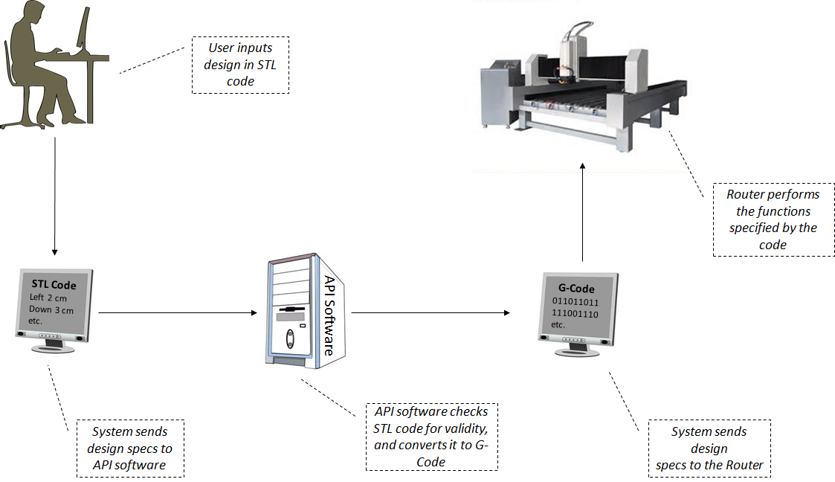

## Product Functionality

While adhering to all safety protocols, the user will input a parts design into the system using STL code. After validating the formatting of the STL code, the API will translate that code into G-Code, a language that can be understood and used by the router. The router will perform the functions specified by the code to produce a low-cost FW-MAV part.

## Users and Characteristics

Initially, the router will be used by the WSU CSE department. Once fully operational, it will be marketed to other universities and the NSF (National Science Foundation). However, the class of users will remain the same; engineering students and faculty working on FW-MAVs. Other departments or entities (commercial, military, etc.) may use router to machine different kinds of parts, but this is outside the scope of the marketing effort.

## Operating Environment

The router is intended primarily for light commercial use in a university setting, and will come with its own set of safety features and protocols.

## Design and Implementation Constraints

- Input language must be STL (subsequently converted to G-code)

- Router will only be capable of machining certain materials

- Physical size limitations will be location-specific

- Customer is responsible for viability of design

-OSHA and other safety protocols must be observed

## User Documentation

In addition to the router and accompanying software, a training manual on how to assemble and use the equipment will also be provided. Documentation detailing the safety protocols will be included with the final product.

## Assumptions and Dependencies

-Adequate funding will be available

-The workspace will be available when necessary

-Current infrastructure will support the new hardware

-The current software system employed by the WSU CSE department will not change during the life of this project

-Only suitable materials will be milled

# Specific Requirements

## External Interfaces

### User Interfaces

Users will have the ability to create their STL files on whichever system they feel most comfortable. These files can then be transferred to the host computer via email or removable drive. Using a CLI (Comman Line Interface) the user will be able to run the STL-to-G-code conversion program and subsequently transmit this code to the router.

### Hardware Interfaces

The instructions received from the user will be then inerpreted by the API’s associated with the stepper motors and translated into physical motion by the machine. A protective shroud will be secured around the router, with an interlock that disables the machine if the doors are opened during the milling process.

### Software Interfaces

Once the STL file is received, the conversion program will run an analysis to validate the syntax of the file to avoid errors and potential damage to the router. This validation will be accomplished using Lex (a lexical analyzer) and the yacc parser generator. Once the file has been validated, the conversion will begin, producing viable G-code instructions than can be sent to the router.

### Communications Interfaces

External communication with the router will be ahcieved via physical connection to a dedicated host node located in the room with the router. This ensures physical proximity with the machine so the process can be monitored.

## Functional Requirements

Validate STL code for formatting – The software will use a lexical analyzer and a parser to determine if the STL code received is in an acceptable format for conversion to G-code.

Convert STL code to G-code – The software will take STL code of acceptable format and convert it to G-code so that it is readable by the router.

Transmit G-code to the router – The system will send the G-code information to the router

Create parts – The router will use the G-code designs to machine physical parts out of raw material.

# Other Non-Functional Requirements

## Performance Requirements

No known performace requirements at this time.

## Safety Requirements

The danger from flying debris shall be mitigated by the shroud placed around the router. This shroud will also serve to dampen noise from the machine. To reduce the risk of entanglement, the shroud will have an interlock to cut power if the doors are opened. The router will also preform a “slow start” to avoid entanglement. Vibration sensors will mitigate the risk associated with machine failure. The design of the router, as well as all safety protocols will conform to OSHA standards. See safety protocol document for additional safety protocols.

## Software Quality Requirements

The software will be testable in a quantifiable manner. The software will be required to accurately convert user code 100% of the time.

## Hardware Quality Requirements

As the physical router is being provided by WSU, they will be responsible for hardware quality.

# Other Requirements

None at this time. All requirements have been covered by previous sections.